1.1.5. Student Pass or Fail Status
START
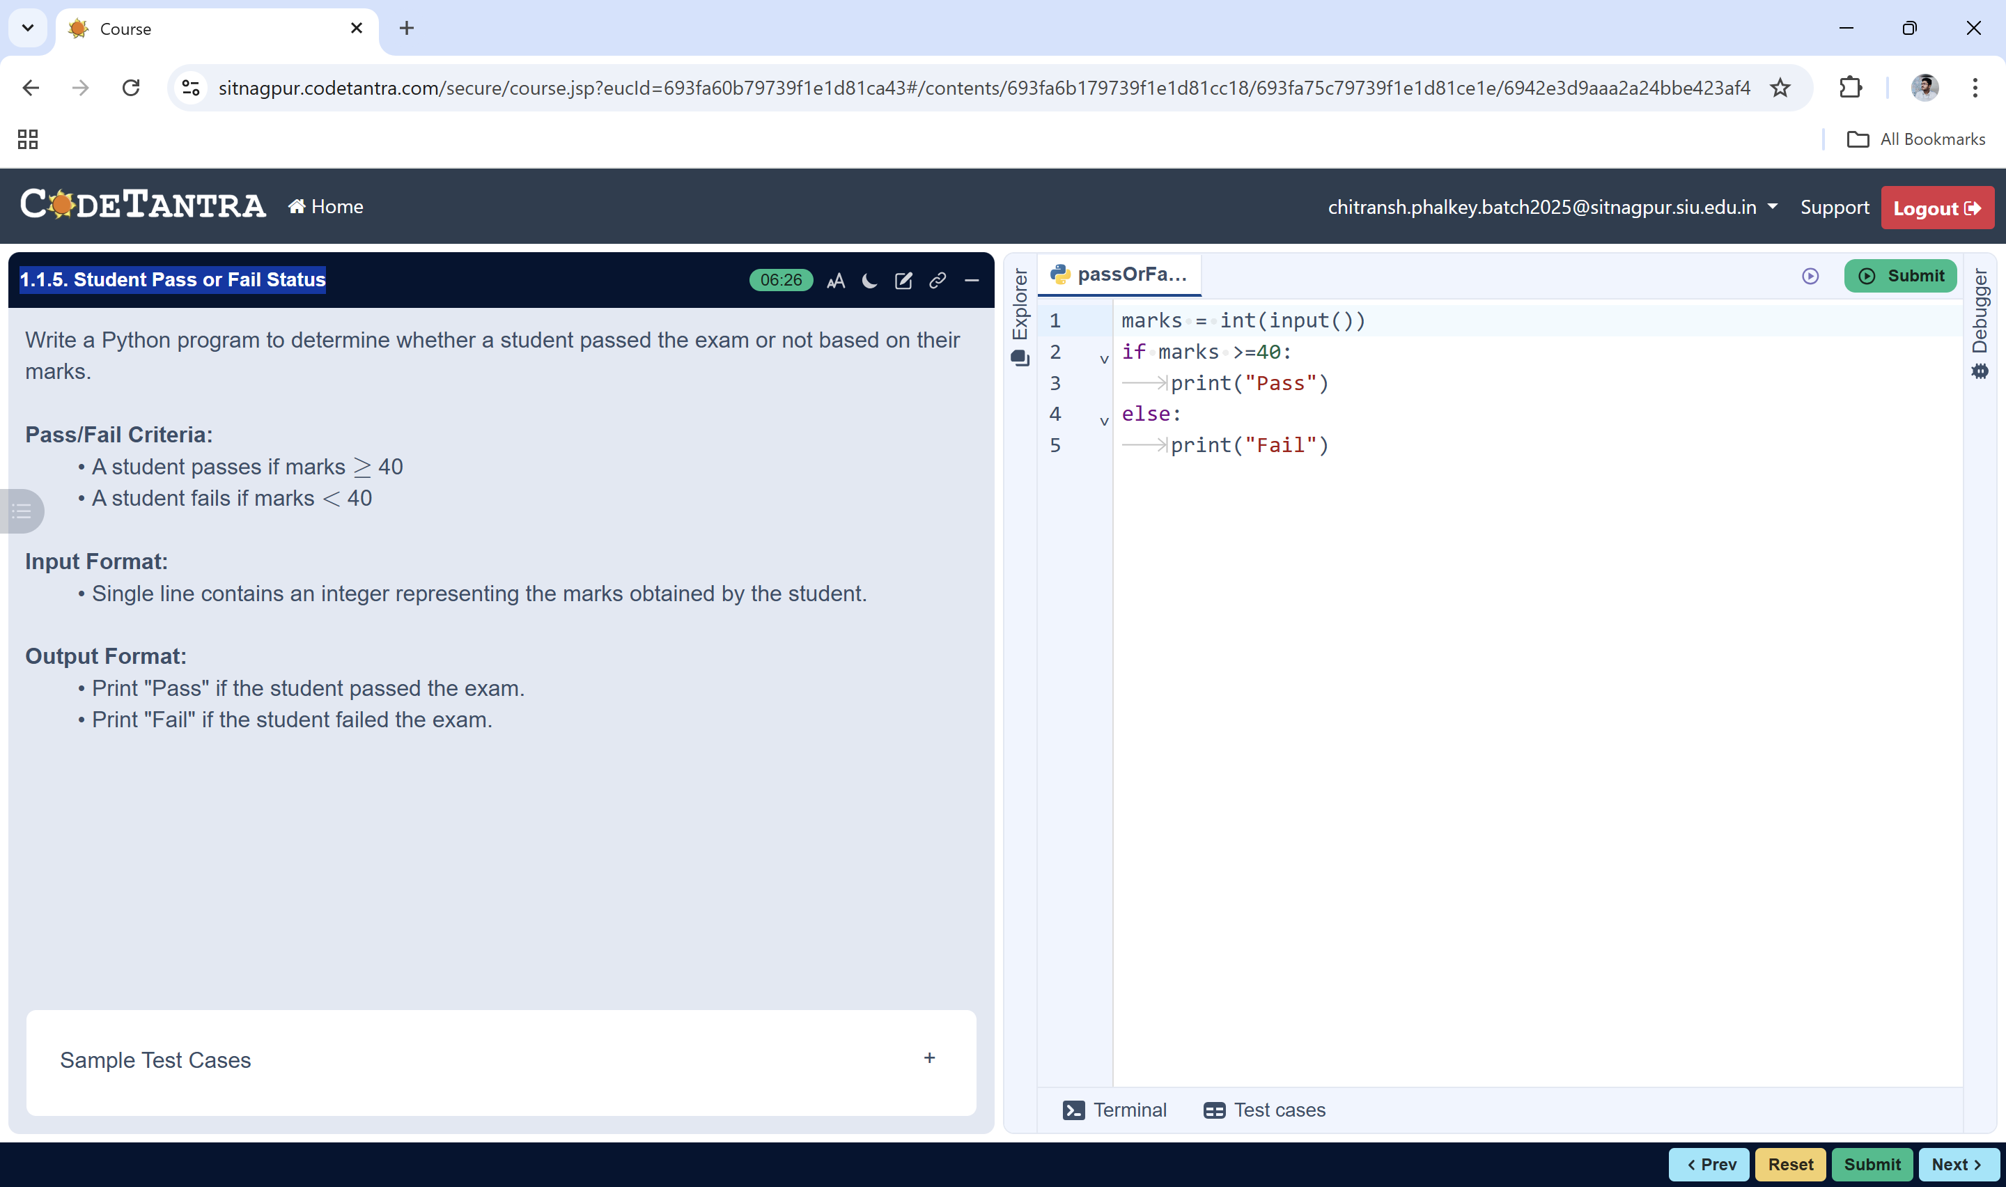
Input marks
Algorithm: Check Pass or Fail
marks ≥ 40 ?
- Start
- Read the value of marks from the user
Print "Fail"
- Check whether marks ≥ 40
Print "Pass"
- If true, display “Pass”
- Else, display “Fail”
- Stop
STOP

